TUTORIAL-WEEK 7 (17-9-26)

- Develop a Java program for a college management system by creating separate packages for Student and Course management. Create a Student class with student details and a Course class with course details. Place each class in its respective package, import them into a Main class, and display the student and course information.
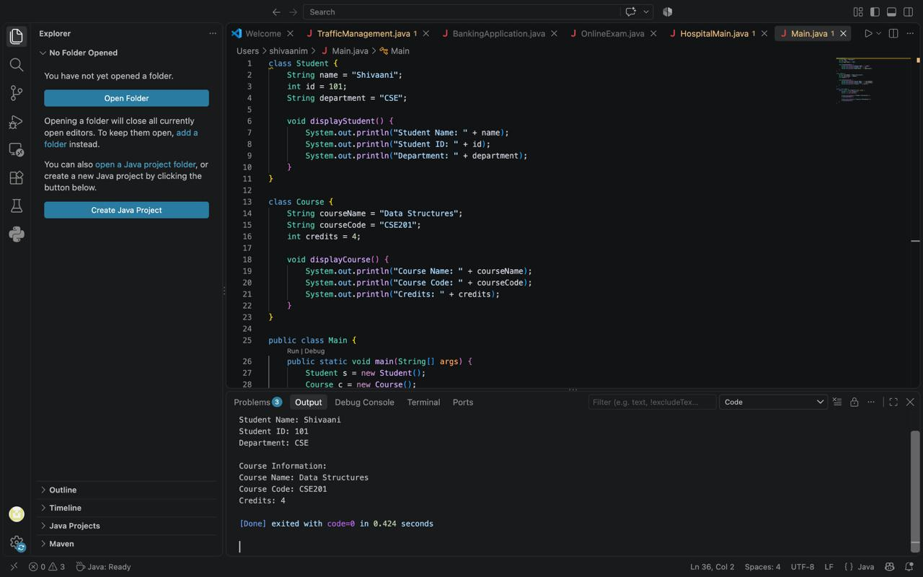

- Develop a Java program for a Hospital Management System using separate packages for doctor and patient management. Create a Doctor class in a doctor package with private data members doctorId, name, specialization, and consultationFee. Create a Patient class in a patient package with private data members patientId, name, disease, and age.
Provide suitable constructors, getter methods, and display methods in both classes. In the Main class:
Import the Doctor and Patient classes from their respective packages.
Create at least two doctors and three patients.
Assign each patient to an appropriate doctor based on the doctor's specialization.
Display the details of each patient along with the details of the doctor treating the patient.
Calculate and display the total consultation fee collected by each doctor based on the number of patients assigned.

package doctor;

public class Doctor {
private int doctorId;
private String name;
private String specialization;
private double consultationFee;
private int patientCount;

public Doctor(int doctorId, String name, String specialization, double consultationFee) {
this.doctorId = doctorId;
this.name = name;
this.specialization = specialization;
this.consultationFee = consultationFee;
this.patientCount = 0;
}

// Getters
public int getDoctorId() {
return doctorId;
}

public String getName() {
return name;
}

public String getSpecialization() {
return specialization;
}

public double getConsultationFee() {
return consultationFee;
}

public int getPatientCount() {
return patientCount;
}

public void addPatient() {
patientCount++;
}

public double getTotalFeeCollected() {
return consultationFee * patientCount;
}

public void displayDoctorInfo() {
System.out.println("Doctor ID : " + doctorId);
System.out.println("Name : Dr. " + name);
System.out.println("Specialization : " + specialization);
System.out.println("Consultation Fee: Rs. " + consultationFee);
}
}
package patient;

public class Patient {
private int patientId;
private String name;
private String disease;
private int age;

public Patient(int patientId, String name, String disease, int age) {
this.patientId = patientId;
this.name = name;
this.disease = disease;
this.age = age;
}

public int getPatientId() {
return patientId;
}

public String getName() {
return name;
}

public String getDisease() {
return disease;
}

public int getAge() {
return age;
}

public void displayPatientInfo() {
System.out.println("Patient ID : " + patientId);
System.out.println("Name : " + name);
System.out.println("Disease : " + disease);
System.out.println("Age : " + age);
}
}
import doctor.Doctor;
import patient.Patient;

public class Main {
public static void main(String[] args) {

Doctor doctor1 = new Doctor(1, "Ramesh Kumar", "Cardiologist", 800.0);
Doctor doctor2 = new Doctor(2, "Anjali Sharma", "Orthopedic", 600.0);

Patient patient1 = new Patient(101, "Manimala", "Heart Pain", 19);
Patient patient2 = new Patient(102, "Suresh Raina", "Fracture", 25);
Patient patient3 = new Patient(103, "Kavya Nair", "Chest Pain", 40);

Doctor[] assignedDoctorForPatient = new Doctor[3];
Patient[] patients = { patient1, patient2, patient3 };

assignedDoctorForPatient[0] = doctor1;
assignedDoctorForPatient[1] = doctor2;
assignedDoctorForPatient[2] = doctor1;
for (Doctor d : assignedDoctorForPatient) {
d.addPatient();
}

System.out.println("===== Hospital Management System =====\n");

for (int i = 0; i < patients.length; i++) {
System.out.println("---- Patient Record " + (i + 1) + " ----");
patients[i].displayPatientInfo();
System.out.println();
System.out.println("Treating Doctor:");
assignedDoctorForPatient[i].displayDoctorInfo();
}

System.out.println("===== Total Consultation Fee Collected =====");
System.out.println("Dr. " + doctor1.getName() + " (" + doctor1.getSpecialization()
+ ") treated " + doctor1.getPatientCount() + " patient(s), Total Fee: Rs. "
+ doctor1.getTotalFeeCollected());

System.out.println("Dr. " + doctor2.getName() + " (" + doctor2.getSpecialization()
+ ") treated " + doctor2.getPatientCount() + " patient(s), Total Fee: Rs. "
+ doctor2.getTotalFeeCollected());
}
}

3.An online examination system performs three activities concurrently: displaying the remaining time, auto-saving the student's answers, and checking the network connection.Develop a Java program by implementing the Runnable interface for these activities. Create separate Thread objects for each task, assign suitable thread names using setName(), and use sleep() to simulate different execution intervals. The run() method should display the name of the currently executing thread and its corresponding activity.
public class OnlineExamSystem {

static class ExamTask implements Runnable {
private String activity;
private int interval;
private int times;

public ExamTask(String activity, int interval, int times) {
this.activity = activity;
this.interval = interval;
this.times = times;
}

public void run() {
for (int i = 1; i <= times; i++) {
System.out.println(Thread.currentThread().getName() + " -> " + activity + " (Check " + i + ")");
try {
Thread.sleep(interval);
} catch (InterruptedException e) {
e.printStackTrace();
}
}
}
}

public static void main(String[] args) {
ExamTask timerTask = new ExamTask("Displaying remaining time", 1000, 5);
ExamTask autoSaveTask = new ExamTask("Auto-saving student answers", 2000, 4);
ExamTask networkTask = new ExamTask("Checking network connection", 1500,5);

Thread timerThread = new Thread(timerTask);
Thread autoSaveThread = new Thread(autoSaveTask);
Thread networkThread = new Thread(networkTask);

timerThread.setName("TimerThread");
autoSaveThread.setName("AutoSaveThread");
networkThread.setName("NetworkThread");

timerThread.start();
autoSaveThread.start();
networkThread.start();
}
}

4.A banking application needs to perform transaction processing, balance updating, and SMS notification as separate concurrent activities. Implement each activity using the Runnable interface. Create the required Thread objects, assign suitable names using setName(), and introduce different delays using sleep(). Each activity should execute three times, displaying its thread name, activity, and execution count.

public class BankingApplication {

static class BankTask implements Runnable {
private String activity;
private int interval;

public BankTask(String activity, int interval) {
this.activity = activity;
this.interval = interval;
}

public void run() {
for (int i = 1; i <= 3; i++) {
System.out.println(Thread.currentThread().getName() + " -> " + activity + " (Execution " + i + ")");
try {
Thread.sleep(interval);
} catch (InterruptedException e) {
e.printStackTrace();
}
}
}
}

public static void main(String[] args) {
BankTask transactionTask = new BankTask("Processing transaction", 1000);
BankTask balanceTask = new BankTask("Updating balance", 1500);
BankTask smsTask = new BankTask("Sending SMS notification", 2000);

Thread transactionThread = new Thread(transactionTask);
Thread balanceThread = new Thread(balanceTask);
Thread smsThread = new Thread(smsTask);

transactionThread.setName("TransactionThread");
balanceThread.setName("BalanceThread");
smsThread.setName("SMSThread");

transactionThread.start();
balanceThread.start();
smsThread.start();
}
}

5.A smart traffic management system simultaneously monitors traffic conditions at three different junctions. Each junction periodically reports its traffic status to the central monitoring system.
Develop a Java program by extending the Thread class to create three threads representing the three traffic junctions. Assign a unique name to each thread using setName(). Override the run() method so that each thread displays its thread name and traffic status three times. Use sleep() with different time intervals for the three threads to simulate different monitoring frequencies.

public class TrafficManagementSystem extends Thread {

private String status;
private int interval;

public TrafficManagementSystem(String name, String status, int interval) {
super(name);
this.status = status;
this.interval = interval;
}

public void run() {
for (int i = 1; i <= 3; i++) {
System.out.println(getName() + " -> " + status + " (Report " + i + ")");
try {
Thread.sleep(interval);
} catch (InterruptedException e) {
e.printStackTrace();
}
}
}

public static void main(String[] args) {
TrafficManagementSystem junction1 = new TrafficManagementSystem("Junction1-Thread", "Traffic is Heavy", 1000);
TrafficManagementSystem junction2 = new TrafficManagementSystem("Junction2-Thread", "Traffic is Moderate", 1500);
TrafficManagementSystem junction3 = new TrafficManagementSystem("Junction3-Thread", "Traffic is Light", 2000);

junction1.start();
junction2.start();
junction3.start();
}
}

